Wire frame

Fig: 1 Ticket Details

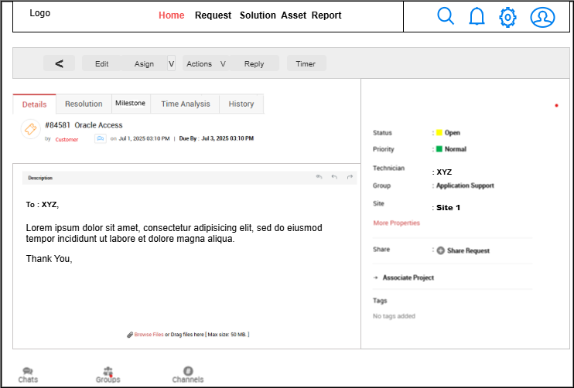

Fig2:

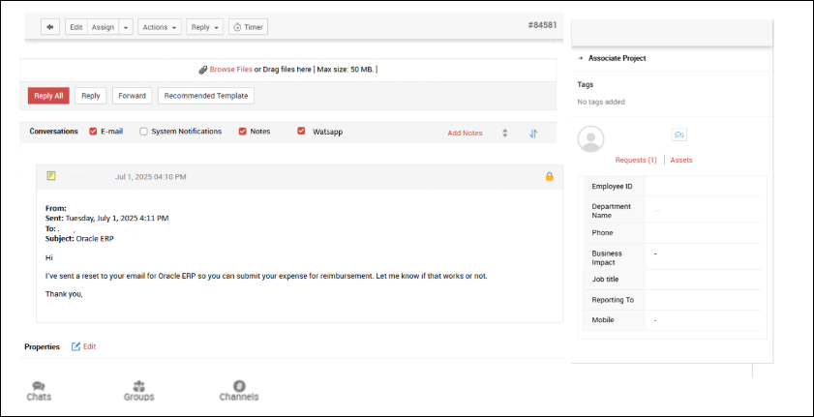

Fig3: Ticket Home

Fig 4: Edit Ticket

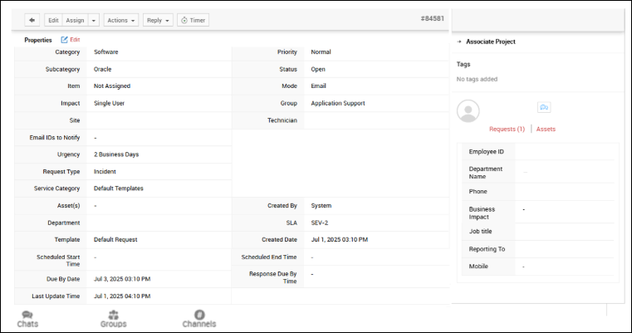

Fig 5 Resolution

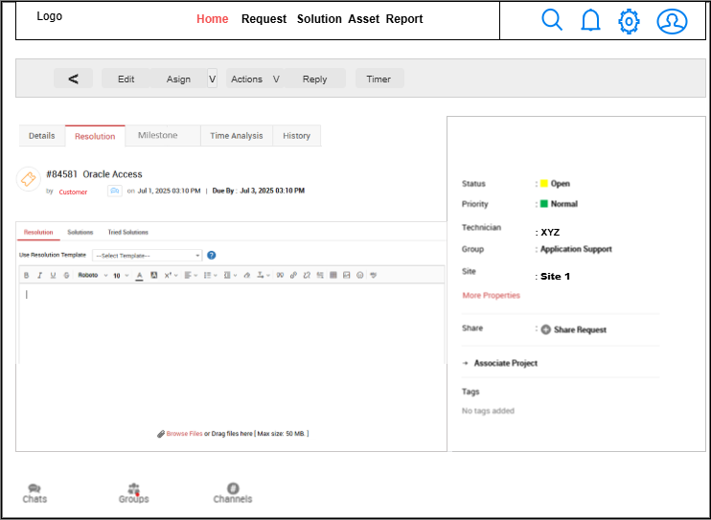

Fig 6: Milestone

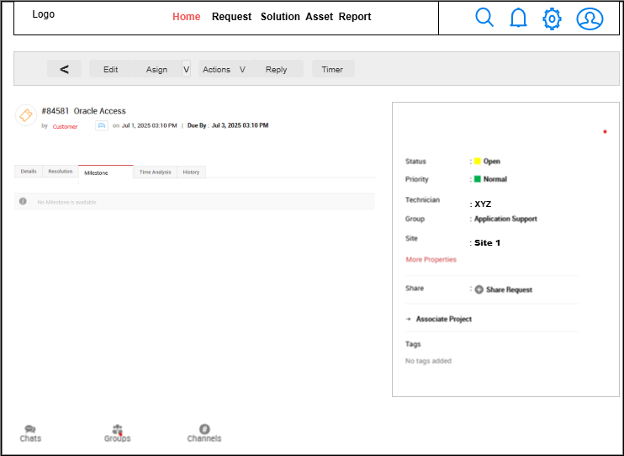

Fig7: Time analysis

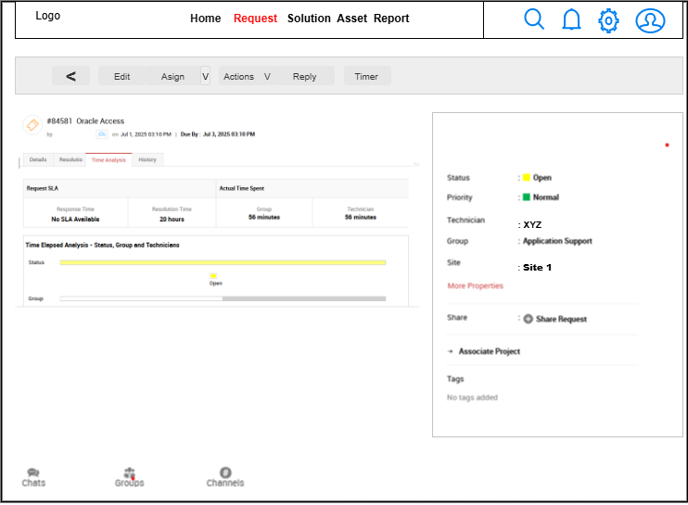

Fig8: Time analysis 2

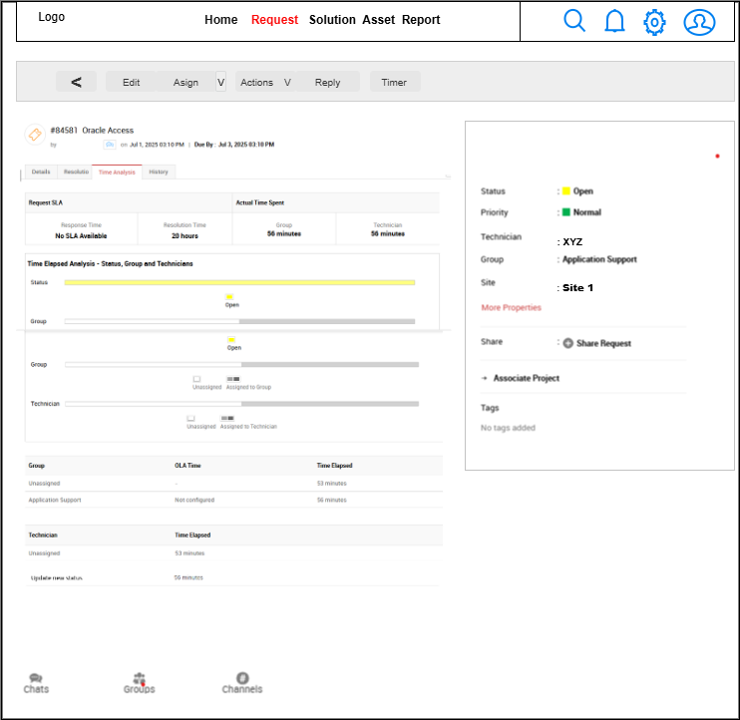

Fig 9: History

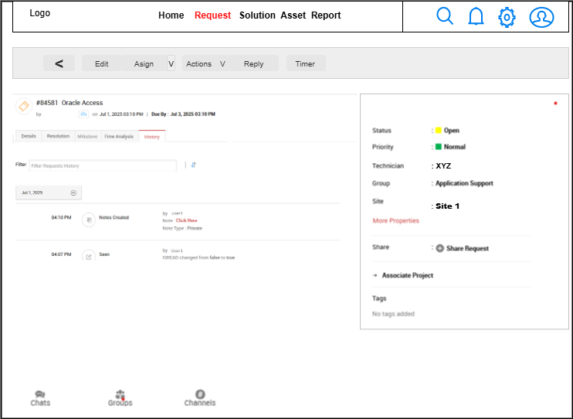

Fig 10: History rest

Fig 11: Request Details

Fig 12: Request Edit full

Fig 13: Request Home

Fig 14: Search in Request

Fig 14: Completed request

Fig 15: Closed Request

Fig 16: Log In

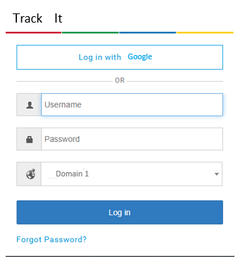

Fig 17: Assets screen

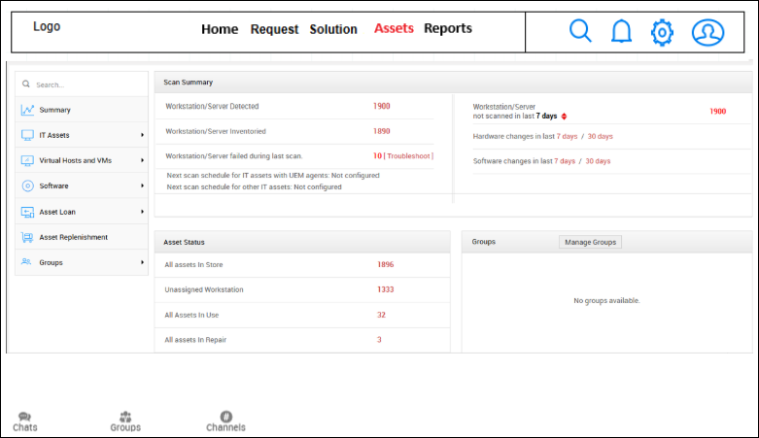

Fig 18: Assets Workstation

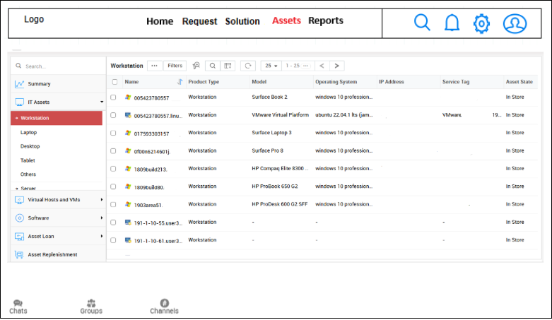

Fig 19: Asset workstation items

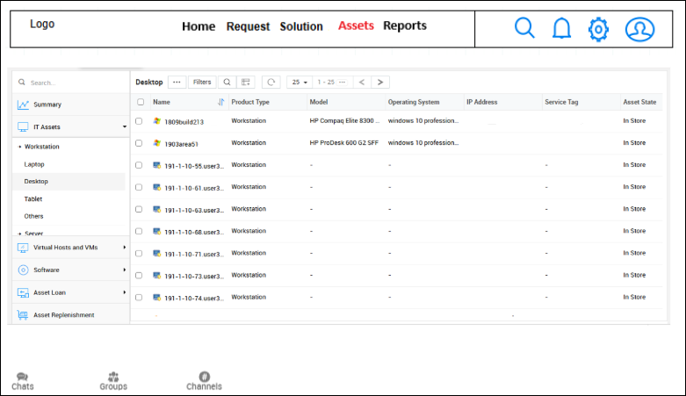

Fig 20: Assets server

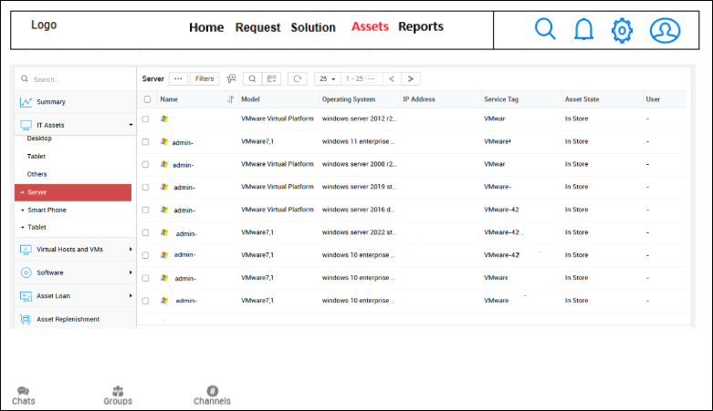

Fig 21: Asserts Monitor

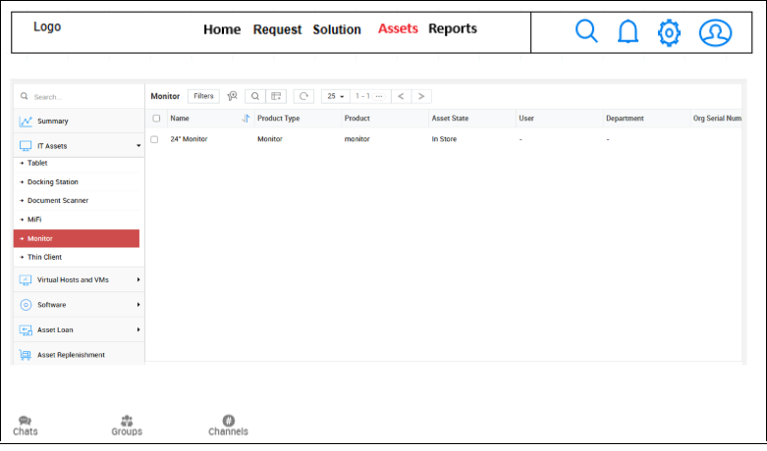

Fig 22 : Assets Virtual host

Fig 22: Virtual Machine

Fig 23: Manage Groups

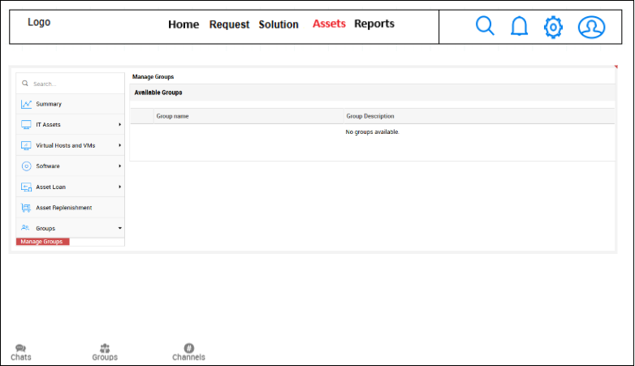

Fig 24: Help

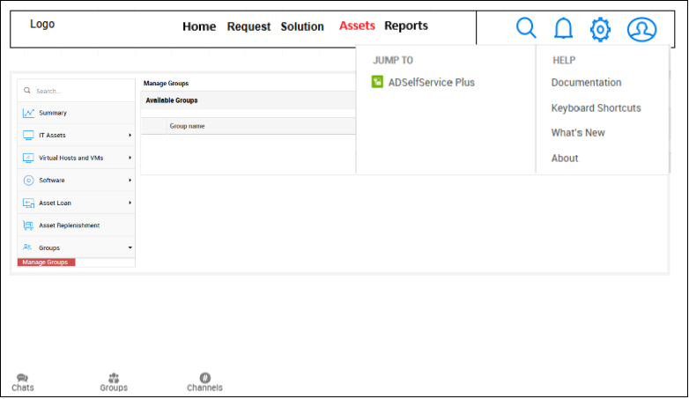

Fig 25 : Solutions

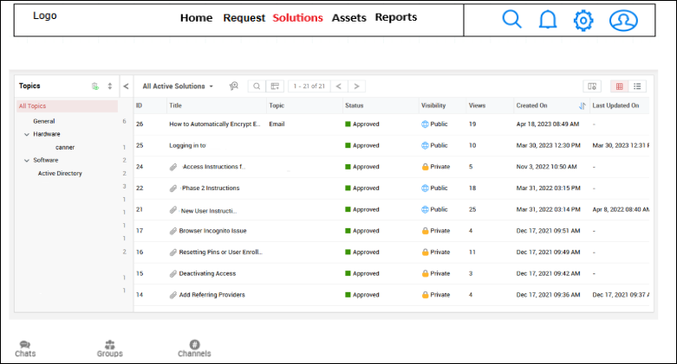

Fig 26: Solution action

